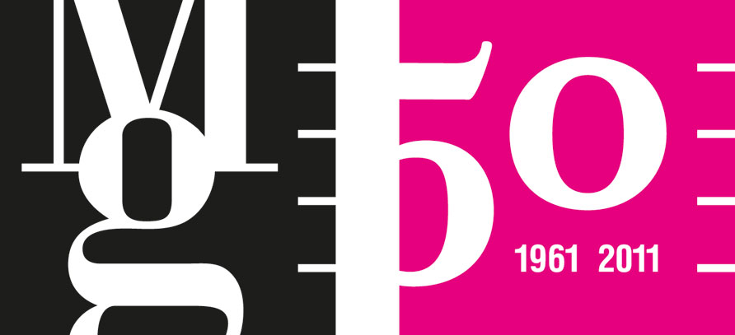

Stories of a Thousand and One Nights

Islamic art from the collections of the Moravian Gallery in Brno

Moravian Gallery in Brno
Tisková zpráva / Press Release

Museum of Applied Arts, Husova 14
22nd April – 31st July 2011
opening 21st April at 17.00

EXHIBITION AUTHOR
Sabina Dvořáková

EXHIBITION CURATOR
Andrea Březinová

ARCHITECTURAL DESIGN OF THE EXHIBITION
Šárka Zíková

GRAPHIC DESIGN OF THE EXHIBITION
Rostislav Vaněk, Tomáš Nedoma

EXHIBIT RESTORATION
Igor Fogaš, Miroslav Kluka, Lukáš Kůra, Marie Zmydlená, Július Karcol, Simona Kronbergerová, Denisa Petrlová, Radomila Hanušová, Vendulka Otavská, Petr Zeman, Střední uměleckoprůmyslová škola and Vyšší odborná škola, Trutnov

PRODUCTION
Miroslava Pluháčková, Petra Trtílková

INSTALLATION
Petr Kolaja, Martin Ondruš, Jiří Šujan

PROMOTION
Kateřina Pacíková, Veronika Pacíková, Martina Vašková

ACCOMPANYING PROGRAMME
Pavlína Vogelová

Visitors to the Moravian Gallery in Brno are now able to experience at least one of the Stories of a Thousand and One Nights thanks to the new exhibition of the same name. Until 31st of July the magical world of the Orient will open its doors to everyone heading towards the Museum of Applied Arts. At the exhibition Stories of a Thousand and One Nights, Islamic art from the collections of the Moravian Gallery in Brno, they will view around 250 artefacts from the Islamic world. Women are sure to be enticed by the very rare hand-woven textiles, collections of jewellery or women’s household shoes. Men will be interested in the examples from the collection of weapons and children will enjoy the objects they are familiar with from fairy-tales. Visitors will also have the rare opportunity to enter the “Oriental room” of a 19th century collector with a passion for all things Oriental. The exhibition also shows a calligrapher’s utensils, mosque lamps and sets of tiles of varied colours and shapes that are used as mosque decorations. The most valuable exhibits are three prayer rugs from the 17th century.
As the collections of the Moravian Gallery in Brno hold almost 400 artefacts connected with the Islamic Orient, only two exhibits on display are on loan – an old encyclopaedia and one photograph from the collection of the Ethnographic Institute of the Moravian Museum in Brno.
Tisková zpráva / Press Release

“The exhibition Stories of a Thousand and One Nights, Islamic art from the collections of the Moravian Gallery in Brno, introduces the Islamic art collection of this institution. The presentation aims to comprehensively show for the first time in the Czech Republic artefacts steeped in the Islamic Orient, whether by their origin or because the Orient provided inspiration for European master craftsmen.
The ensemble of almost 240 exhibits reveals the skills of the Islamic world from Morocco via the Balkans and the Middle East to Iran. The artefacts were made to serve a purpose rather than for pleasure, so it is therefore principally misleading to call them art. The approach to art in Islam is different from the traditional western definition, it is perceived more in relation to everyday life, and hence it appears in its expression rather like arts and crafts.
The most interesting and also most valuable items are found in the textiles section among carpets and samples of woven cloths. The metalwork collection presents traditional household objects made to satisfy the demands of the middle class, which were standard items sold in the 18th – 19th century at Oriental souks. Remarkable artefacts from this category on show include calligrapher’s utensils, ingenious incense burners or mosque lamps. The mosque was also home to the collection of tin-glazed tiles of various shapes and colours originating in the Middle Ages. The fabled perfection of the craftsmanship is represented by lacquerwork boxes and furniture inlaid with mother-of-pearl. Aesthetically appealing is the collection of women’s jewellery from the traditional region of the Arabian Peninsula. The men’s world is represented at the exhibition by cutting weapons and firearms. The final exceptional chapter is made up of Orient--influenced items — objects of European provenance inspired by the Orient, usually made of glass or ceramics.
The cultural, political and economic relationships between Europe and the Orient have drawn the attention of researchers and the general public. Our rich shared history is a key to understanding the often complex topical situations. One of the possible roads to take in order to obtain up-to-date information on the background of the Islamic world leads via the common meeting points in the culture of both worlds.”
Sabina Dvořáková
exhibition author

The items displayed in the exhibition are grouped by the material used — metalwork, ceramics, textiles, lacquerwork and woodwork. We can also find thematic divisions such as Orientalism, weapons and armour, jewellery.
The artefacts also provide an outstanding example of most of the principal manufacturing techniques applied in the Islamic Orient: hammered and cast metal objects decorated by chasing, inlays, niello, perforation, enamel or punching, old brocade cloths and various embroidery, Oriental lacquerwork or woodcarving and wood with tortoise inlays.

”The exhibition and publication dedicated to the newly constituted collection of Islamic art are proof of the necessity for continual reviews and verification of what it actually is that the Moravian Gallery in Brno — and all the other art museums – holds in its collections and what it should present to the public – again, for the first time or in a different context. The exhibition Stories of a Thousand and One Nights presents for the very first time artefacts from the collections of the Moravian Gallery in Brno that can be gathered under the Islamic art umbrella as a virtual whole the individual parts of which are otherwise kept and registered in the individual subsections classified by material. Actually, a number of artefacts in the collection had not been previously identified as being of Oriental provenance. The careful research work and insight of Sabina Dvořáková as the author of the project made it possible to newly (and correctly) determine many works of art and to form the idea of this specific whole that began to materialize shortly after the foundation of the Museum of Applied Arts in Brno by a series of purchases and gifts the systematic nature of which can be doubted but it grew to what it is today regardless. The exhibition and the publication provide a view of the history of acquiring the collection while they simultaneously create the actual collection and make it presentable to the public.“
Tisková zpráva / Press Release

Marek Pokorný
director Moravian Gallery in Brno

ACCOMPANYING PROGRAMME TO THE EXHIBITION

Brno Museum Night 14. 5. 2011

Museum of Applied Arts, Husova 14
19.00, 21.00, 22.00 Stories of a Thousand and One Nights / guided tour
18.00–23.00 A Thousand Ornaments and One Night / art workshop focused on the art of the ornament
23.00 Museum Night Surprise inspired by the Orient that will not leave you cold
Free admission

18. 5. at 19.00, Improvisation inspired by the Stories of a Thousand and One Nights exhibition
Improvisation session — open musical-dramatical improvisation session in collaboration with Josef Zajíček (Útulek Theatre).
Governor’s Palace, Moravské nám. 1a, free admission

19. 5. at 10.00, Done! Painted! At an Oriental Souk, art workshop for children with parents
19. 5. at 16.00, Done! Painted! Stories of a Thousand and One Nights, art workshop for children with parents

21. 5. 15.00–18.00, Ornament / glass mosaic, on order, Kalod Studio, Palackého 80
Art workshop for adults. A paraphrase of Oriental art with glass mosaic. Rich inspiration to be found at the exhibition. 120 CZK

21. 5. at 16.00, The art of craft / self-discovery meeting for adults
A fresh view of things in our life that we consider ordinary, important, exceptional. An attempt to reconsider our current set of values. Imagination and its artistic reflection using a freely selected technique. 120 CZK / for SMPG members 60 CZK

26. 5. A Magic Lamp and an Ebony Horse
60 CZK, one parent free, second child 30 CZK

28. 5. at 10.00–12.00, Orient Express
Art workshop for children, 3186 km of new experiences and discoveries at the Stories of a Thousand and One Nights exhibition. A travel through the regions of the Islamic Orient from Morocco via the Balkans, the Middle East and Iran to northern India. 40 CZK

MEDIA PARTNERS


Tisková zpráva / Press Release

CONTACT FOR MEDIA
Martina Vašková, marketing and communication, +420 724 516 672, +420 532 169 174
tisk@moravska-galerie.cz

